

**Saroni Global Business Pvt. Ltd.**

Head office: 2nd Floor, Ganesh Market, LIC Buiding, Near UCO Bank, Narengi Tiniali, Guwahati, Assam, India, PIN: 781026

Mob: +91-7002329489 / 9859931042

Email: trade@saroniglobal.com

Pusa Raw Basmati Rice

**Specifications**

| Purity | – 95.00% |
| --- | --- |
| Natural Admixture | – 5.00% |
| Average Grain Length | – 7.45 MM |
| Moisture | – 12.5% Max. |
| Broken Grain | – 1% Max. |
| Damage/Discolour Grain | – 1% Max. |
| Immature Grain | – 1% Max. |
| Foreign Matter | – Nil |
| Packaging Type | – Jute bag, PP bag, Non-woven bag or as per buyer’s choice. |
| Supply Ability | – 2000 tons Per Week |
| Main Export Market(S) | – Europe, USA, Australia, Saudi Arabia, Kuwait, Egypt, UAE, Jordan, Oman, Bahrain, Yemen, Syria, Iraq, UAE, Libya, Turkey |
| Delivery Time | – 15 Days |

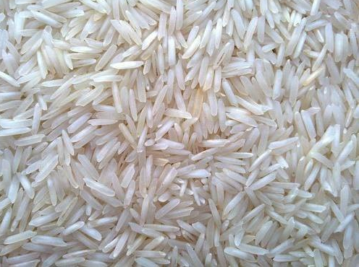

Pusa Sella Basmati Rice

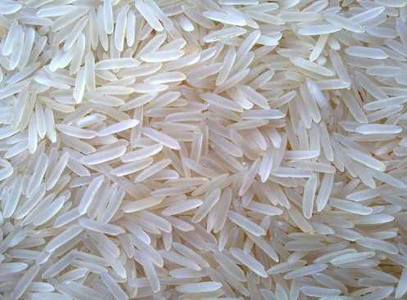**Specifications**

| Purity | – 95.00% |
| --- | --- |
| Natural Admixture | – 5.00% |
| Average Grain Length | – 7.45 MM |
| Moisture | – 12.5% Max. |
| Broken Grain | – 1% Max. |
| Damage/Discolour Grain | – 1% Max. |
| Immature Grain | – 1% Max. |
| Foreign Matter | – Nil |
| Packaging Type | – Jute bag, PP bag, Non-woven bag or as per buyer’s choice. |
| Supply Ability | – 2000 tons Per Week |
| Main Export Market(S) | – Europe, USA, Australia, Saudi Arabia, Kuwait, Egypt, UAE, Jordan, Oman, Bahrain, Yemen, Syria, Iraq, UAE, Libya, Turkey |
| Delivery Time | – 15 Days |



Pusa Steam Basmati Rice

**Specifications**

| Purity | – 95.00% |
| --- | --- |
| Natural Admixture | – 5.00% |
| Average Grain Length | – 7.45 MM |
| Moisture | – 12.5% Max. |
| Broken Grain | – 1% Max. |
| Damage/Discolour Grain | – 1% Max. |
| Immature Grain | – 1% Max. |
| Foreign Matter | – Nil |
| Packaging Type | – Jute bag, PP bag, Non-woven bag or as per buyer’s choice. |
| Supply Ability | – 2000 tons Per Week |
| Main Export Market(S) | – Europe, USA, Australia, Saudi Arabia, Kuwait, Egypt, UAE, Jordan, Oman, Bahrain, Yemen, Syria, Iraq, UAE, Libya, Turkey |
| Delivery Time | – 15 Days |

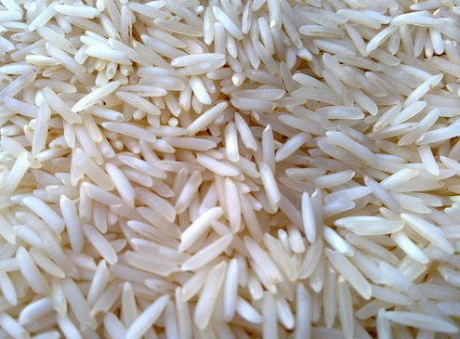



Pusa Golden Sella Basmati Rice

**Specifications**

| Purity | – 95.00% |
| --- | --- |
| Natural Admixture | – 5.00% |
| Average Grain Length | – 7.30 MM |
| Moisture | – 12.5% Max. |
| Broken Grain | – 1% Max. |
| Damage/Discolour Grain | – 1% Max. |
| Immature Grain | – 1% Max. |
| Foreign Matter | – Nil |
| Packaging Type | – Jute bag, PP bag, Non-woven bag or as per buyer’s choice. |
| Supply Ability | – 2000 tons Per Week |
| Main Export Market(S) | – Europe, USA, Australia, Saudi Arabia, Kuwait, Egypt, UAE, Jordan, Oman, Bahrain, Yemen, Syria, Iraq, UAE, Libya, Turkey |
| Delivery Time | – 15 Days |

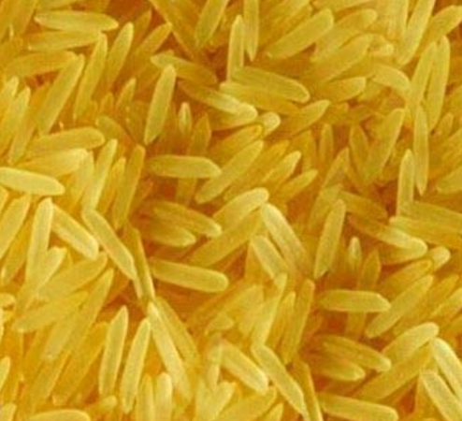



1401 Sella Basmati Rice

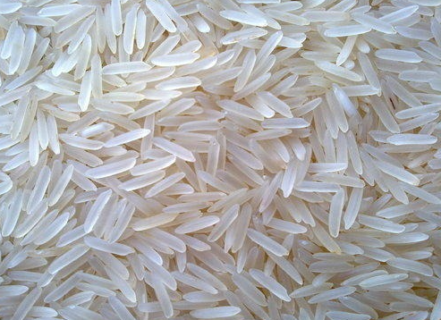**Specifications**

| Purity | – 95.00% |
| --- | --- |
| Natural Admixture | – 5.00% |
| Average Grain Length | – 7.70 MM |
| Moisture | – 12.5% Max. |
| Broken Grain | – 1% Max. |
| Damage/Discolour Grain | – 1% Max. |
| Immature Grain | – 1% Max. |
| Foreign Matter | – Nil |
| Packaging Type | – Jute bag, PP bag, Non-woven bag or as per buyer’s choice. |
| Supply Ability | – 2000 tons Per Week |
| Main Export Market(S) | – Europe, USA, Australia, Saudi Arabia, Kuwait, Egypt, UAE, Jordan, Oman, Bahrain, Yemen, Syria, Iraq, UAE, Libya, Turkey |
| Delivery Time | – 15 Days |



1401 Steam Basmati Rice

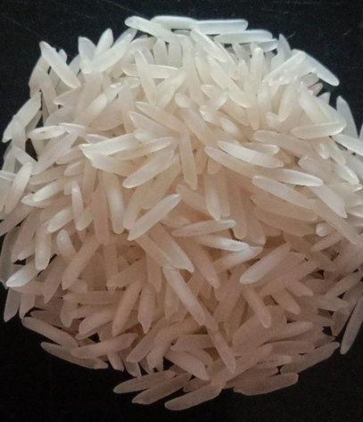**Specifications**

| Purity | – 95.00% |
| --- | --- |
| Natural Admixture | – 5.00% |
| Average Grain Length | – 7.70 MM |
| Moisture | – 12.5% Max. |
| Broken Grain | – 1% Max. |
| Damage/Discolour Grain | – 1% Max. |
| Immature Grain | – 1% Max. |
| Foreign Matter | – Nil |
| Packaging Type | – Jute bag, PP bag, Non-woven bag or as per buyer’s choice. |
| Supply Ability | – 2000 tons Per Week |
| Main Export Market(S) | – Europe, USA, Australia, Saudi Arabia, Kuwait, Egypt, UAE, Jordan, Oman, Bahrain, Yemen, Syria, Iraq, UAE, Libya, Turkey |
| Delivery Time | – 15 Days |



1121 Sella Basmati Rice

**Specifications**

| Purity | – 95.00% |
| --- | --- |
| Natural Admixture | – 5.00% |
| Average Grain Length | – 8.35 MM |
| Moisture | – 12.5% Max. |
| Broken Grain | – 1% Max. |
| Damage/Discolour Grain | – 1% Max. |
| Immature Grain | – 1% Max. |
| Foreign Matter | – Nil |
| Packaging Type | – Jute bag, PP bag, Non-woven bag or as per buyer’s choice. |
| Supply Ability | – 2000 tons Per Week |
| Main Export Market(S) | – Europe, USA, Australia, Saudi Arabia, Kuwait, Egypt, UAE, Jordan, Oman, Bahrain, Yemen, Syria, Iraq, UAE, Libya, Turkey |
| Delivery Time | – 15 Days |

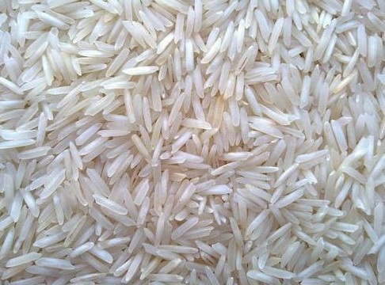



1121 RAW Basmati Rice

**Specifications**

| Purity | – 95.00% |
| --- | --- |
| Natural Admixture | – 5.00% |
| Average Grain Length | – 8.35 MM |
| Moisture | – 12.5% Max. |
| Broken Grain | – 1% Max. |
| Damage/Discolour Grain | – 1% Max. |
| Immature Grain | – 1% Max. |
| Foreign Matter | – Nil |
| Packaging Type | – Jute bag, PP bag, Non-woven bag or as per buyer’s choice. |
| Supply Ability | – 2000 tons Per Week |
| Main Export Market(S) | – Europe, USA, Australia, Saudi Arabia, Kuwait, Egypt, UAE, Jordan, Oman, Bahrain, Yemen, Syria, Iraq, UAE, Libya, Turkey |
| Delivery Time | – 15 Days |

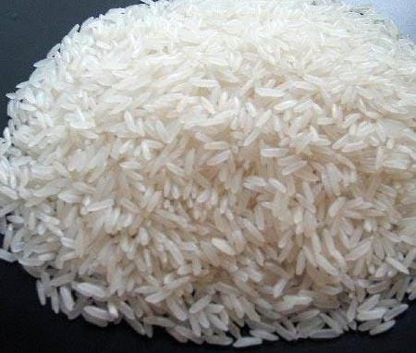

1121 Steam Basmati Rice

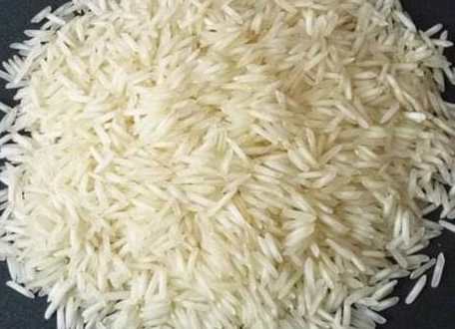**Specifications**

| Purity | – 95.00% |
| --- | --- |
| Natural Admixture | – 5.00% |
| Average Grain Length | – 8.35 MM |
| Moisture | – 12.5% Max. |
| Broken Grain | – 1% Max. |
| Damage/Discolour Grain | – 1% Max. |
| Immature Grain | – 1% Max. |
| Foreign Matter | – Nil |
| Packaging Type | – Jute bag, PP bag, Non-woven bag or as per buyer’s choice. |
| Supply Ability | – 2000 tons Per Week |
| Main Export Market(S) | – Europe, USA, Australia, Saudi Arabia, Kuwait, Egypt, UAE, Jordan, Oman, Bahrain, Yemen, Syria, Iraq, UAE, Libya, Turkey |
| Delivery Time | – 15 Days |



1121 Golden Sella Basmati Rice

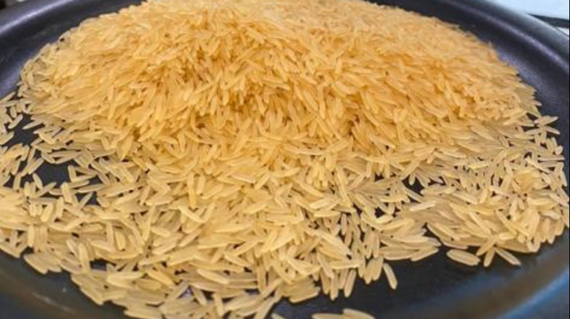**Specifications**

| Purity | – 95.00% |
| --- | --- |
| Natural Admixture | – 5.00% |
| Average Grain Length | – 8.30 MM |
| Moisture | – 12.5% Max. |
| Broken Grain | – 1% Max. |
| Damage/Discolour Grain | – 1% Max. |
| Immature Grain | – 1% Max. |
| Foreign Matter | – Nil |
| Packaging Type | – Jute bag, PP bag, Non-woven bag or as per buyer’s choice. |
| Supply Ability | – 2000 tons Per Week |
| Main Export Market(S) | – Europe, USA, Australia, Saudi Arabia, Kuwait, Egypt, UAE, Jordan, Oman, Bahrain, Yemen, Syria, Iraq, UAE, Libya, Turkey |
| Delivery Time | – 15 Days |



1509 Sella Basmati Rice

**Specifications**

| Purity | – 95.00% |
| --- | --- |
| Natural Admixture | – 5.00% |
| Average Grain Length | – 8.40 MM |
| Moisture | – 12.5% Max. |
| Broken Grain | – 1% Max. |
| Damage/Discolour Grain | – 1% Max. |
| Immature Grain | – 1% Max. |
| Foreign Matter | – Nil |
| Packaging Type | – Jute bag, PP bag, Non-woven bag or as per buyer’s choice. |
| Supply Ability | – 2000 tons Per Week |
| Main Export Market(S) | – Europe, USA, Australia, Saudi Arabia, Kuwait, Egypt, UAE, Jordan, Oman, Bahrain, Yemen, Syria, Iraq, UAE, Libya, Turkey |
| Delivery Time | – 15 Days |

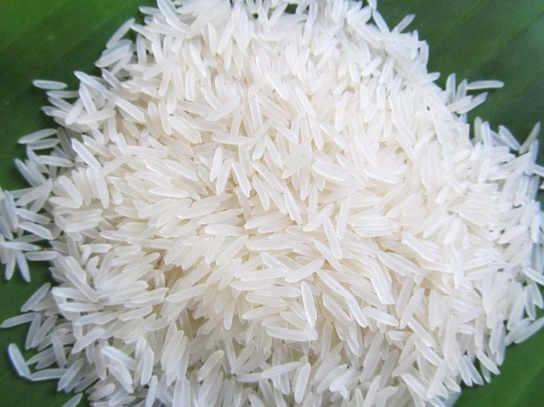



1509 Steam Basmati Rice

**Specifications**

| Purity | – 95.00% |
| --- | --- |
| Natural Admixture | – 5.00% |
| Average Grain Length | – 8.40 MM |
| Moisture | – 12.5% Max. |
| Broken Grain | – 1% Max. |
| Damage/Discolour Grain | – 1% Max. |
| Immature Grain | – 1% Max. |
| Foreign Matter | – Nil |
| Packaging Type | – Jute bag, PP bag, Non-woven bag or as per buyer’s choice. |
| Supply Ability | – 2000 tons Per Week |
| Main Export Market(S) | – Europe, USA, Australia, Saudi Arabia, Kuwait, Egypt, UAE, Jordan, Oman, Bahrain, Yemen, Syria, Iraq, UAE, Libya, Turkey |
| Delivery Time | – 15 Days |

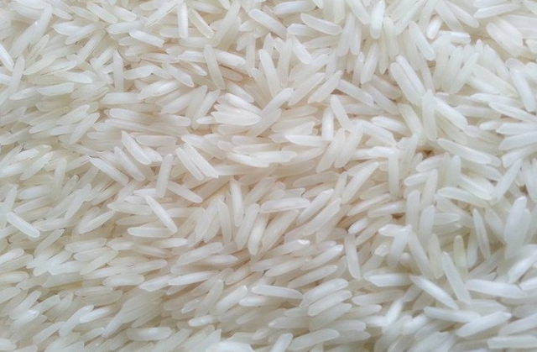



1509 Golden Sella Basmati Rice

**Specifications**

| Purity | – 95.00% |
| --- | --- |
| Natural Admixture | – 5.00% |
| Average Grain Length | – 8.35 MM |
| Moisture | – 12.5% Max. |
| Broken Grain | – 1% Max. |
| Damage/Discolour Grain | – 1% Max. |
| Immature Grain | – 1% Max. |
| Foreign Matter | – Nil |
| Packaging Type | – Jute bag, PP bag, Non-woven bag or as per buyer’s choice. |
| Supply Ability | – 2000 tons Per Week |
| Main Export Market(S) | – Europe, USA, Australia, Saudi Arabia, Kuwait, Egypt, UAE, Jordan, Oman, Bahrain, Yemen, Syria, Iraq, UAE, Libya, Turkey |
| Delivery Time | – 15 Days |



Sugandha Raw Basmati Rice

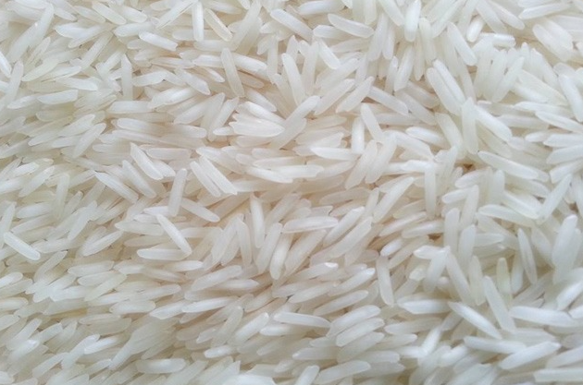**Specifications**

| Purity | – 95.00% |
| --- | --- |
| Natural Admixture | – 5.00% |
| Average Grain Length | – 7.30 MM |
| Moisture | – 12.5% Max. |
| Broken Grain | – 1% Max. |
| Damage/Discolour Grain | – 1% Max. |
| Immature Grain | – 1% Max. |
| Foreign Matter | – Nil |
| Packaging Type | – Jute bag, PP bag, Non-woven bag or as per buyer’s choice. |
| Supply Ability | – 2000 tons Per Week |
| Main Export Market(S) | – Europe, USA, Australia, Saudi Arabia, Kuwait, Egypt, UAE, Jordan, Oman, Bahrain, Yemen, Syria, Iraq, UAE, Libya, Turkey |
| Delivery Time | – 15 Days |



Sugandha Golden Sella Basmati Rice

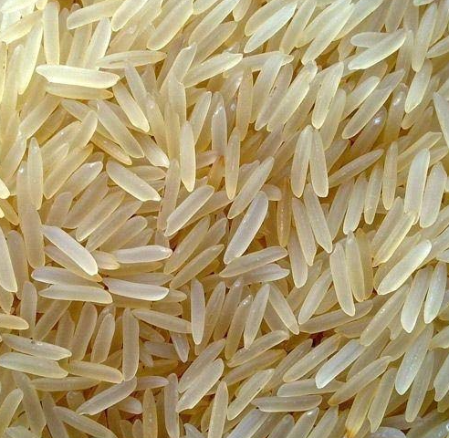**Specifications**

| Purity | – 95.00% |
| --- | --- |
| Natural Admixture | – 5.00% |
| Average Grain Length | – 7.30 MM |
| Moisture | – 12.5% Max. |
| Broken Grain | – 1% Max. |
| Damage/Discolour Grain | – 1% Max. |
| Immature Grain | – 1% Max. |
| Foreign Matter | – Nil |
| Packaging Type | – Jute bag, PP bag, Non-woven bag or as per buyer’s choice. |
| Supply Ability | – 2000 tons Per Week |
| Main Export Market(S) | – Europe, USA, Australia, Saudi Arabia, Kuwait, Egypt, UAE, Jordan, Oman, Bahrain, Yemen, Syria, Iraq, UAE, Libya, Turkey |
| Delivery Time | – 15 Days |



Sugandha Sella Basmati Rice

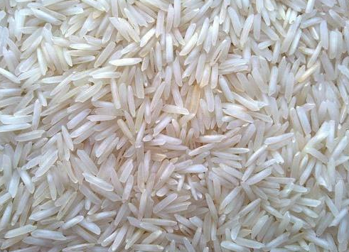**Specifications**

| Purity | – 95.00% |
| --- | --- |
| Natural Admixture | – 5.00% |
| Average Grain Length | – 7.30 MM |
| Moisture | – 12.5% Max. |
| Broken Grain | – 1% Max. |
| Damage/Discolour Grain | – 1% Max. |
| Immature Grain | – 1% Max. |
| Foreign Matter | – Nil |
| Packaging Type | – Jute bag, PP bag, Non-woven bag or as per buyer’s choice. |
| Supply Ability | – 2000 tons Per Week |
| Main Export Market(S) | – Europe, USA, Australia, Saudi Arabia, Kuwait, Egypt, UAE, Jordan, Oman, Bahrain, Yemen, Syria, Iraq, UAE, Libya, Turkey |
| Delivery Time | – 15 Days |



Sugandha Steam Basmati Rice

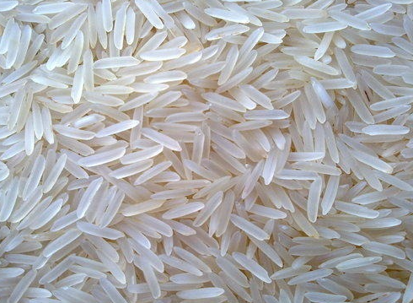**Specifications**

| Purity | – 95.00% |
| --- | --- |
| Natural Admixture | – 5.00% |
| Average Grain Length | – 7.30 MM |
| Moisture | – 12.5% Max. |
| Broken Grain | – 1% Max. |
| Damage/Discolour Grain | – 1% Max. |
| Immature Grain | – 1% Max. |
| Foreign Matter | – Nil |
| Packaging Type | – Jute bag, PP bag, Non-woven bag or as per buyer’s choice. |
| Supply Ability | – 2000 tons Per Week |
| Main Export Market(S) | – Europe, USA, Australia, Saudi Arabia, Kuwait, Egypt, UAE, Jordan, Oman, Bahrain, Yemen, Syria, Iraq, UAE, Libya, Turkey |
| Delivery Time | – 15 Days |



Sharbati Sella Basmati Rice

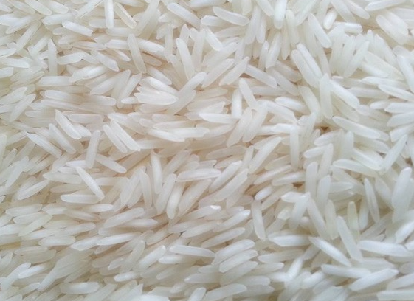**Specifications**

| Purity | – 95.00% |
| --- | --- |
| Natural Admixture | – 5.00% |
| Average Grain Length | – 7.30 MM |
| Moisture | – 12.5% Max. |
| Broken Grain | – 1% Max. |
| Damage/Discolour Grain | – 1% Max. |
| Immature Grain | – 1% Max. |
| Foreign Matter | – Nil |
| Packaging Type | – Jute bag, PP bag, Non-woven bag or as per buyer’s choice. |
| Supply Ability | – 2000 tons Per Week |
| Main Export Market(S) | – Europe, USA, Australia, Saudi Arabia, Kuwait, Egypt, UAE, Jordan, Oman, Bahrain, Yemen, Syria, Iraq, UAE, Libya, Turkey |
| Delivery Time | – 15 Days |



Sharbati Raw Basmati Rice

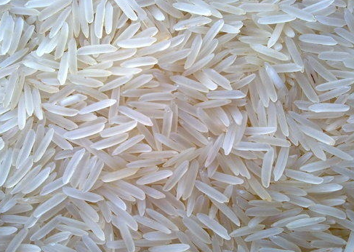**Specifications**

| Purity | – 95.00% |
| --- | --- |
| Natural Admixture | – 5.00% |
| Average Grain Length | – 7.30 MM |
| Moisture | – 12.5% Max. |
| Broken Grain | – 1% Max. |
| Damage/Discolour Grain | – 1% Max. |
| Immature Grain | – 1% Max. |
| Foreign Matter | – Nil |
| Packaging Type | – Jute bag, PP bag, Non-woven bag or as per buyer’s choice. |
| Supply Ability | – 2000 tons Per Week |
| Main Export Market(S) | – Europe, USA, Australia, Saudi Arabia, Kuwait, Egypt, UAE, Jordan, Oman, Bahrain, Yemen, Syria, Iraq, UAE, Libya, Turkey |
| Delivery Time | – 15 Days |



Sharbati Steam Basmati Rice

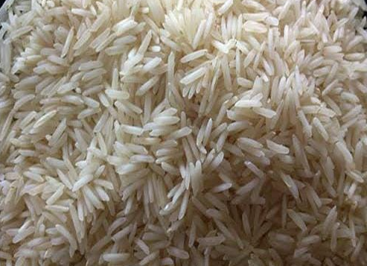**Specifications**

| Purity | – 95.00% |
| --- | --- |
| Natural Admixture | – 5.00% |
| Average Grain Length | – 7.30 MM |
| Moisture | – 12.5% Max. |
| Broken Grain | – 1% Max. |
| Damage/Discolour Grain | – 1% Max. |
| Immature Grain | – 1% Max. |
| Foreign Matter | – Nil |
| Packaging Type | – Jute bag, PP bag, Non-woven bag or as per buyer’s choice. |
| Supply Ability | – 2000 tons Per Week |
| Main Export Market(S) | – Europe, USA, Australia, Saudi Arabia, Kuwait, Egypt, UAE, Jordan, Oman, Bahrain, Yemen, Syria, Iraq, UAE, Libya, Turkey |
| Delivery Time | – 15 Days |



PR11 Raw Non Basmati Rice

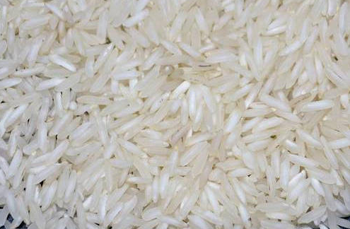**Specifications**

| Purity | – 95.00% |
| --- | --- |
| Natural Admixture | – 5.00% |
| Average Grain Length | – 7.30 MM |
| Moisture | – 12.5% Max. |
| Broken Grain | – 1% Max. |
| Damage/Discolour Grain | – 1% Max. |
| Immature Grain | – 1% Max. |
| Foreign Matter | – Nil |
| Packaging Type | – Jute bag, PP bag, Non-woven bag or as per buyer’s choice. |
| Supply Ability | – 2000 tons Per Week |
| Main Export Market(S) | – Europe, USA, Australia, Saudi Arabia, Kuwait, Egypt, UAE, Jordan, Oman, Bahrain, Yemen, Syria, Iraq, UAE, Libya, Turkey |
| Delivery Time | – 15 Days |



PR11 Sella Non Basmati Rice

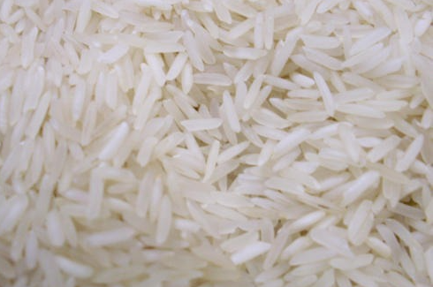**Specifications**

| Purity | – 95.00% |
| --- | --- |
| Natural Admixture | – 5.00% |
| Average Grain Length | – 7.30 MM |
| Moisture | – 12.5% Max. |
| Broken Grain | – 1% Max. |
| Damage/Discolour Grain | – 1% Max. |
| Immature Grain | – 1% Max. |
| Foreign Matter | – Nil |
| Packaging Type | – Jute bag, PP bag, Non-woven bag or as per buyer’s choice. |
| Supply Ability | – 2000 tons Per Week |
| Main Export Market(S) | – Europe, USA, Australia, Saudi Arabia, Kuwait, Egypt, UAE, Jordan, Oman, Bahrain, Yemen, Syria, Iraq, UAE, Libya, Turkey |
| Delivery Time | – 15 Days |



PR11 Steam Non Basmati Rice

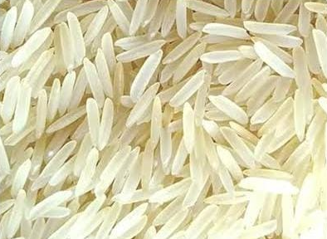**Specifications**

| Purity | – 95.00% |
| --- | --- |
| Natural Admixture | – 5.00% |
| Average Grain Length | – 7.30 MM |
| Moisture | – 12.5% Max. |
| Broken Grain | – 1% Max. |
| Damage/Discolour Grain | – 1% Max. |
| Immature Grain | – 1% Max. |
| Foreign Matter | – Nil |
| Packaging Type | – Jute bag, PP bag, Non-woven bag or as per buyer’s choice. |
| Supply Ability | – 2000 tons Per Week |
| Main Export Market(S) | – Europe, USA, Australia, Saudi Arabia, Kuwait, Egypt, UAE, Jordan, Oman, Bahrain, Yemen, Syria, Iraq, UAE, Libya, Turkey |
| Delivery Time | – 15 Days |



### PR11 Golden Sella Non Basmati Rice

**Specifications**

| Purity | – 95.00% |
| --- | --- |
| Natural Admixture | – 5.00% |
| Average Grain Length | – 7.30 MM |
| Moisture | – 12.5% Max. |
| Broken Grain | – 1% Max. |
| Damage/Discolour Grain | – 1% Max. |
| Immature Grain | – 1% Max. |
| Foreign Matter | – Nil |
| Packaging Type | – Jute bag, PP bag, Non-woven bag or as per buyer’s choice. |
| Supply Ability | – 2000 tons Per Week |
| Main Export Market(S) | – Europe, USA, Australia, Saudi Arabia, Kuwait, Egypt, UAE, Jordan, Oman, Bahrain, Yemen, Syria, Iraq, UAE, Libya, Turkey |
| Delivery Time | – 15 Days |

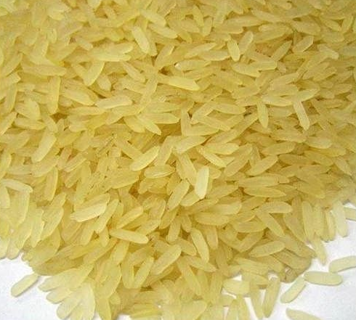

PR14 Raw Non Basmati Rice

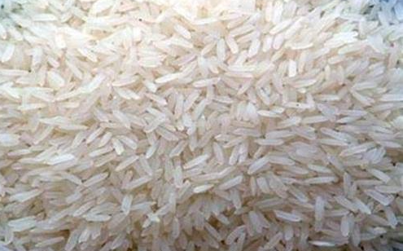**Specifications**

| Purity | – 95.00% |
| --- | --- |
| Natural Admixture | – 5.00% |
| Average Grain Length | – 7.30 MM |
| Moisture | – 12.5% Max. |
| Broken Grain | – 1% Max. |
| Damage/Discolour Grain | – 1% Max. |
| Immature Grain | – 1% Max. |
| Foreign Matter | – Nil |
| Packaging Type | – Jute bag, PP bag, Non-woven bag or as per buyer’s choice. |
| Supply Ability | – 2000 tons Per Week |
| Main Export Market(S) | – Europe, USA, Australia, Saudi Arabia, Kuwait, Egypt, UAE, Jordan, Oman, Bahrain, Yemen, Syria, Iraq, UAE, Libya, Turkey |
| Delivery Time | – 15 Days |



PR14 Sella Non Basmati Rice

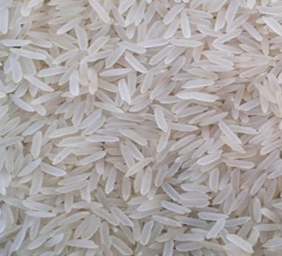**Specifications**

| Purity | – 95.00% |
| --- | --- |
| Natural Admixture | – 5.00% |
| Average Grain Length | – 7.30 MM |
| Moisture | – 12.5% Max. |
| Broken Grain | – 1% Max. |
| Damage/Discolour Grain | – 1% Max. |
| Immature Grain | – 1% Max. |
| Foreign Matter | – Nil |
| Packaging Type | – Jute bag, PP bag, Non-woven bag or as per buyer’s choice. |
| Supply Ability | – 2000 tons Per Week |
| Main Export Market(S) | – Europe, USA, Australia, Saudi Arabia, Kuwait, Egypt, UAE, Jordan, Oman, Bahrain, Yemen, Syria, Iraq, UAE, Libya, Turkey |
| Delivery Time | – 15 Days |



PR14 Steam Non Basmati Rice

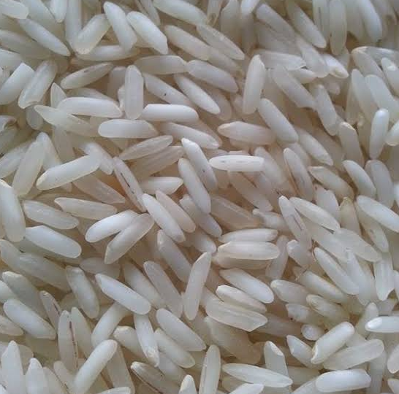**Specifications**

| Purity | – 95.00% |
| --- | --- |
| Natural Admixture | – 5.00% |
| Average Grain Length | – 7.30 MM |
| Moisture | – 12.5% Max. |
| Broken Grain | – 1% Max. |
| Damage/Discolour Grain | – 1% Max. |
| Immature Grain | – 1% Max. |
| Foreign Matter | – Nil |
| Packaging Type | – Jute bag, PP bag, Non-woven bag or as per buyer’s choice. |
| Supply Ability | – 2000 tons Per Week |
| Main Export Market(S) | – Europe, USA, Australia, Saudi Arabia, Kuwait, Egypt, UAE, Jordan, Oman, Bahrain, Yemen, Syria, Iraq, UAE, Libya, Turkey |
| Delivery Time | – 15 Days |



PR14 Golden Sella Non Basmati Rice

**Specifications**

| Purity | – 95.00% |
| --- | --- |
| Natural Admixture | – 5.00% |
| Average Grain Length | – 7.30 MM |
| Moisture | – 12.5% Max. |
| Broken Grain | – 1% Max. |
| Damage/Discolour Grain | – 1% Max. |
| Immature Grain | – 1% Max. |
| Foreign Matter | – Nil |
| Packaging Type | – Jute bag, PP bag, Non-woven bag or as per buyer’s choice. |
| Supply Ability | – 2000 tons Per Week |
| Main Export Market(S) | – Europe, USA, Australia, Saudi Arabia, Kuwait, Egypt, UAE, Jordan, Oman, Bahrain, Yemen, Syria, Iraq, UAE, Libya, Turkey |
| Delivery Time | – 15 Days |

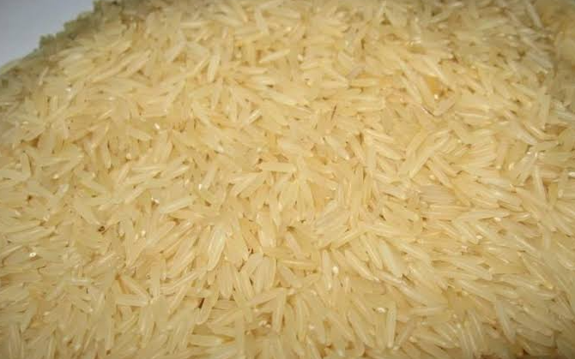

Parmal Sella Non Basmati Rice

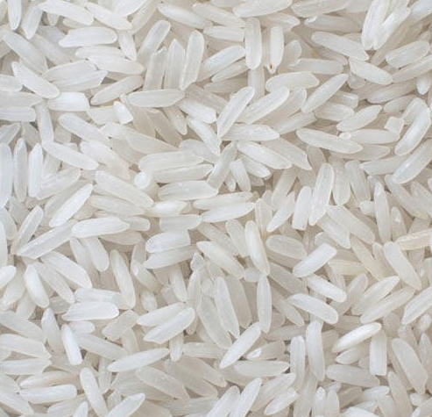**Specifications**

| Purity | – 95.00% |
| --- | --- |
| Natural Admixture | – 5.00% |
| Average Grain Length | – 7.30 MM |
| Moisture | – 12.5% Max. |
| Broken Grain | – 1% Max. |
| Damage/Discolour Grain | – 1% Max. |
| Immature Grain | – 1% Max. |
| Foreign Matter | – Nil |
| Packaging Type | – Jute bag, PP bag, Non-woven bag or as per buyer’s choice. |
| Supply Ability | – 2000 tons Per Week |
| Main Export Market(S) | – Europe, USA, Australia, Saudi Arabia, Kuwait, Egypt, UAE, Jordan, Oman, Bahrain, Yemen, Syria, Iraq, UAE, Libya, Turkey |
| Delivery Time | – 15 Days |



### Parmal Raw Non Basmati Rice

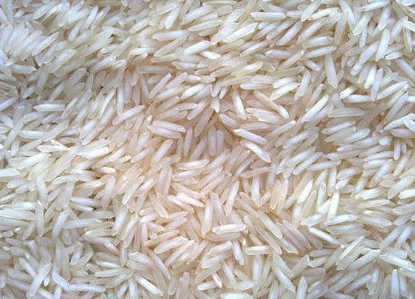**Specifications**

| Purity | – 95.00% |
| --- | --- |
| Natural Admixture | – 5.00% |
| Average Grain Length | – 7.30 MM |
| Moisture | – 12.5% Max. |
| Broken Grain | – 1% Max. |
| Damage/Discolour Grain | – 1% Max. |
| Immature Grain | – 1% Max. |
| Foreign Matter | – Nil |
| Packaging Type | – Jute bag, PP bag, Non-woven bag or as per buyer’s choice. |
| Supply Ability | – 2000 tons Per Week |
| Main Export Market(S) | – Europe, USA, Australia, Saudi Arabia, Kuwait, Egypt, UAE, Jordan, Oman, Bahrain, Yemen, Syria, Iraq, UAE, Libya, Turkey |
| Delivery Time | – 15 Days |



Parmal Steam Non Basmati Rice

**Specifications**

| Purity | – 95.00% |
| --- | --- |
| Natural Admixture | – 5.00% |
| Average Grain Length | – 7.30 MM |
| Moisture | – 12.5% Max. |
| Broken Grain | – 1% Max. |
| Damage/Discolour Grain | – 1% Max. |
| Immature Grain | – 1% Max. |
| Foreign Matter | – Nil |
| Packaging Type | – Jute bag, PP bag, Non-woven bag or as per buyer’s choice. |
| Supply Ability | – 2000 tons Per Week |
| Main Export Market(S) | – Europe, USA, Australia, Saudi Arabia, Kuwait, Egypt, UAE, Jordan, Oman, Bahrain, Yemen, Syria, Iraq, UAE, Libya, Turkey |
| Delivery Time | – 15 Days |

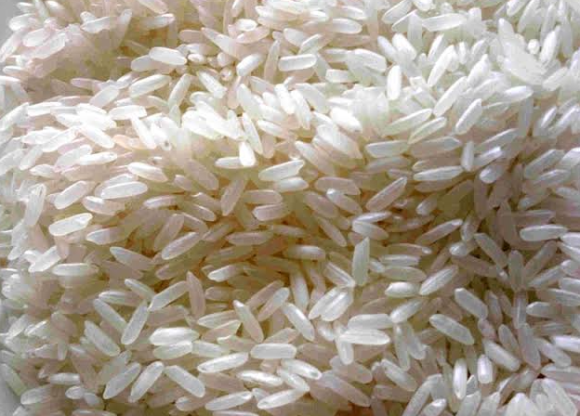

Parmal Golden Sella Non Basmati Rice

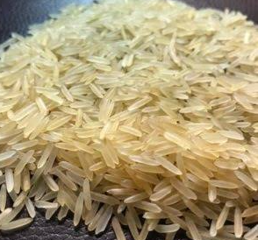**Specifications**

| Purity | – 95.00% |
| --- | --- |
| Natural Admixture | – 5.00% |
| Average Grain Length | – 7.30 MM |
| Moisture | – 12.5% Max. |
| Broken Grain | – 1% Max. |
| Damage/Discolour Grain | – 1% Max. |
| Immature Grain | – 1% Max. |
| Foreign Matter | – Nil |
| Packaging Type | – Jute bag, PP bag, Non-woven bag or as per buyer’s choice. |
| Supply Ability | – 2000 tons Per Week |
| Main Export Market(S) | – Europe, USA, Australia, Saudi Arabia, Kuwait, Egypt, UAE, Jordan, Oman, Bahrain, Yemen, Syria, Iraq, UAE, Libya, Turkey |
| Delivery Time | – 15 Days |

